**TCP/IP Implementation using Python Socket Programming**

**LAB # 11**



**Spring 2025**

Submitted by: **Mohsin Sajjad**

Registration No: **22pwsce2149**

Class Section: **A**

“On my honor, as student of University of Engineering and Technology, I have neither given nor received unauthorized assistance on this academic work.”

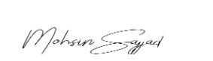

Student Signature: ______________

Submitted to:

**Dr. Yasir Saleem Afridi**

Month Day, Year (30 05, 2025)

Department of Computer Systems Engineering

University of Engineering and Technology, Peshawar

**CSE 303L: Data Communication and Computer Networks**

|  |  |  |  |  |
| --- | --- | --- | --- | --- |
| **Demonstration of Concepts** | **Poor (Does not meet expectation (1))**  The student failed to demonstrate a clear understanding of the assignment concepts | **Fair (Meet Expectation (2-3))**  The student demonstrated a clear understanding of some of the assignment concepts | **Good (Exceeds Expectation (4-5)**  The student demonstrated a clear understanding of the assignment concepts | **Score**  **30%** |
| **Accuracy** | The student mis-configured enough network settings that the lab computer couldn't function properly on the network | The student configured enough network settings that the lab computer partially functioned on the network | The student configured the network settings that the lab computer fully functioned on the network | **30%** |
| **Following Directions** | The student clearly failed to follow the verbal and written instructions to successfully complete the lab | The student failed to follow the some of the verbal and written instructions to successfully complete all requirements of the lab | The student followed the verbal and written instructions to successfully complete requirements of the lab | **20%** |
| **Time Utilization** | The student failed to complete even part of the lab in the allotted amount of time | The student failed to complete the entire lab in the allotted amount of time | The student completed the lab in its entirety in the al | **20%** |

**Credit Hours: 1**

**TCP/IP Implementation using Python Socket Programming**

# **Objectives of Lab**

- To understand the implementation of TCP/IP using Python socket programming.  
- To establish a basic client-server communication system.  
- To explore the functionality of Python’s socket library.

**Introduction to Python Programming**

Python is a high-level, interpreted programming language known for its simplicity and readability. It supports multiple programming paradigms, including procedural, object oriented, and functional programming. Python is widely used in web development, data analysis, artificial intelligence, scientific computing, and network programming. Due to its vast standard library and community support, Python is ideal for rapid application development.

**Introduction to Python Socket Library and Its Various Functions**

Python’s socket module provides a standard way of networking in Python and is used for implementing clients and servers. It supports both TCP and UDP protocols.

**Key functions used in this lab:**

* socket.socket() –
* Creates a new socket object.
* bind() – Associates the socket with a specific IP and port.
* listen() – Enables a server to accept connections.
* accept() – Accepts a connection request from a client.
* connect() – Connects a client to a server.
* send() / sendall()
* Sends data from the client to the server.
* recv() – Receives data from the connection.
* close() – Closes the socket.

**CODE:**

**Server:**

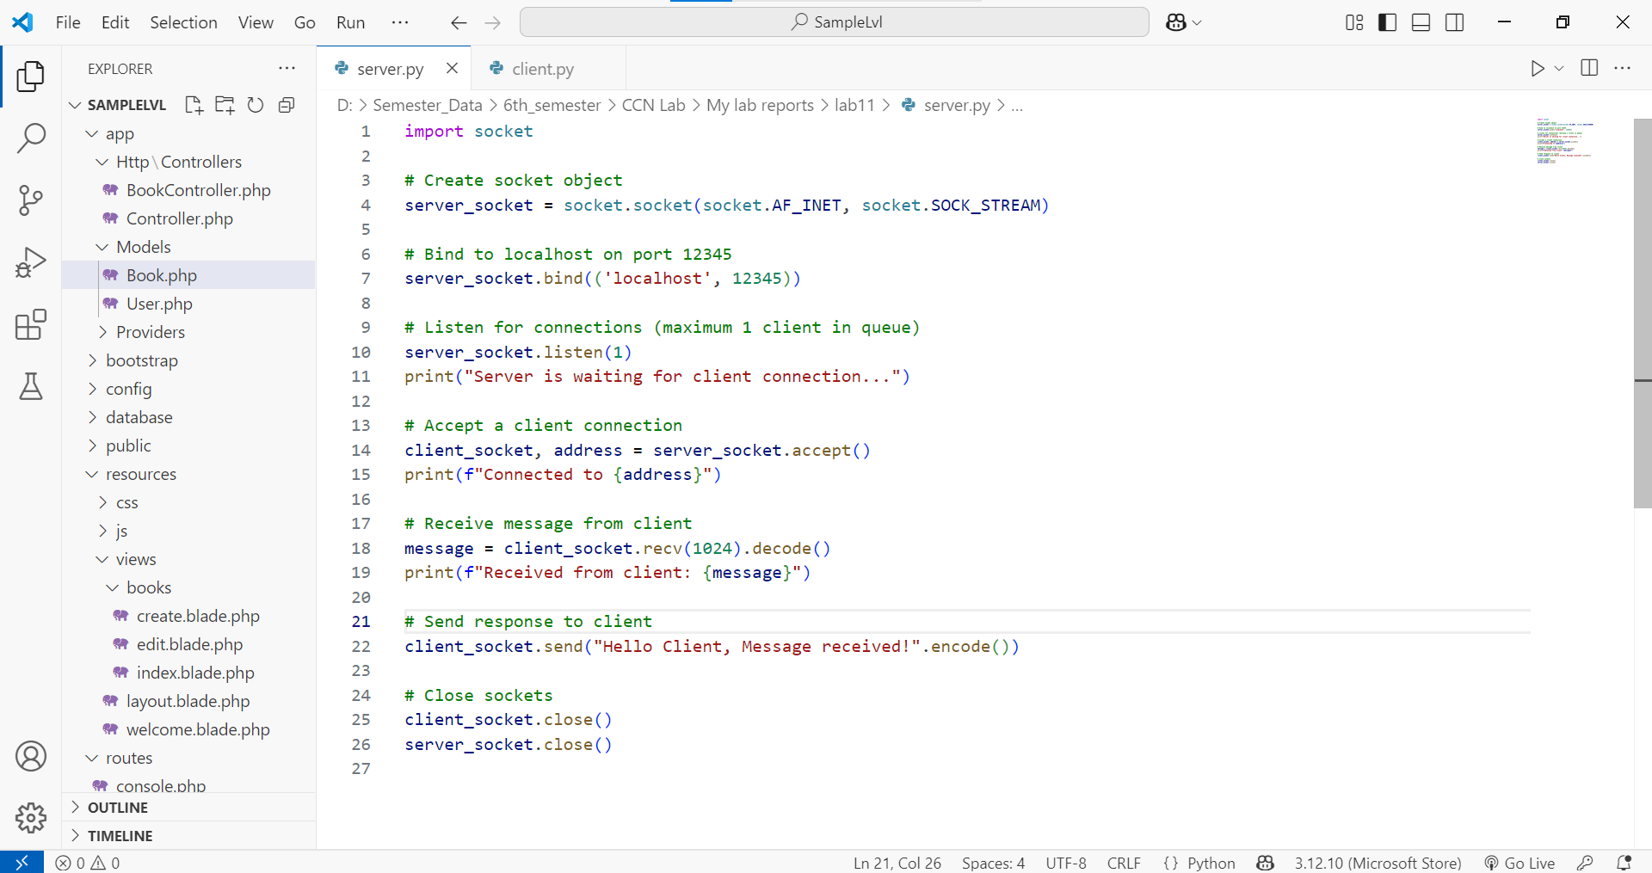**CLIENT:**

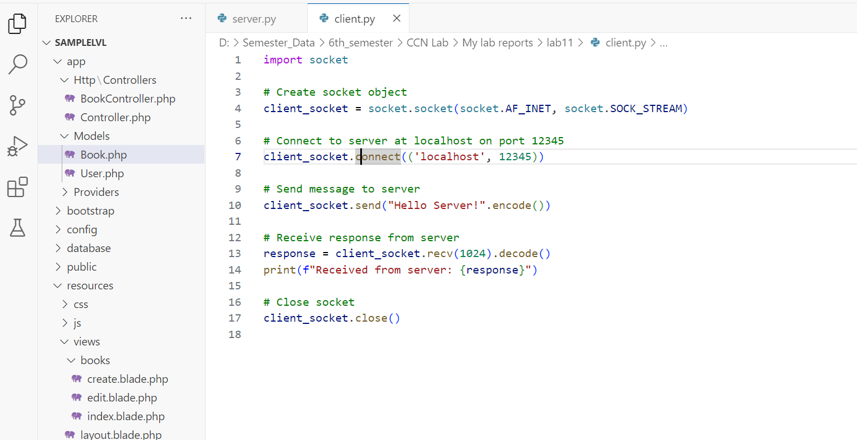

**Output:  
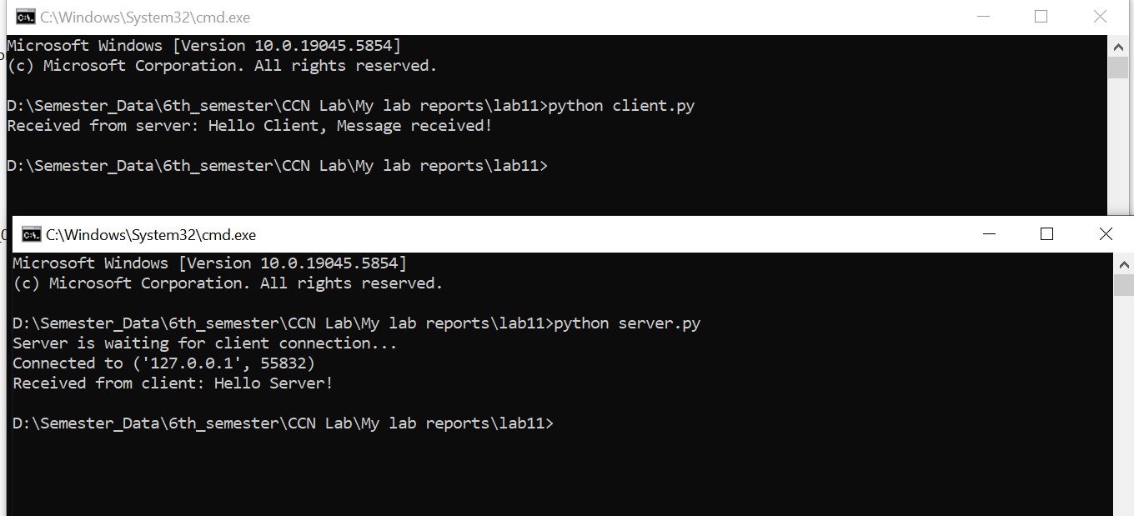**

**Conclusion:**

This lab successfully demonstrated the fundamentals of TCP/IP communication using Python's socket programming. We implemented a basic client-server model where a client sends a message to a server and receives a confirmation in response. This lays the foundation for understanding more advanced network communication systems.